For more information on
Knight Masonry
Contact
The Grand Scribe
Grand Council of Knight Masons
Freemasons’ Hall
17-19 Molesworth St.
Dublin 2
Ireland
Email: council@freemason.ie
Tel: +353 1 67 61 337

www.knight-masons.com

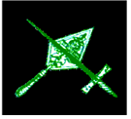

The Chivalric Order
of
Knight Masons

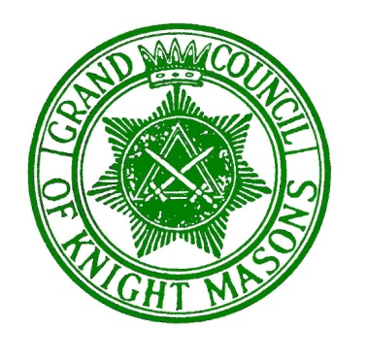

What is the Order of Knight Masons?

Knight Masonry is a chivalric fraternal Masonic Order which confers three Degrees of high symbolic, philosophical and moral value. These Masonic Degrees continue the story of the Temple in Jerusalem and in an Irish context completes the Masonic Legend of the Temple.

The Degrees in Knight Masonry are:

The Red Cross of Daniel or The Babylonian Pass referred to as Knight of the Sword.
The Jordan Pass referred to as Knight of the East.
The Royal Order referred to as Knight of the East and West.

Plus the Degree of Installed Excellent Chief for a Sir Knight elected to preside over a Council.

While the subject matter of these degrees can be found within various Masonic Orders around the world, only in the Irish working under the Grand Council of Knight Masons are they communicated in the most detail and in their complete and correct form.

The content of the Degrees seems to be as old as Freemasonry itself and for centuries it has been regarded as a vital part of the Masonic Journey.

The Grand Council of Knight Masons was formed in 1923 to preserve, practice and perpetuate these degrees, the duty having been previously held by the Supreme Grand Encampment (now the Great Priory of Ireland). Today the Order of Knight Masons is rapidly growing in membership with the ever developing presence of Councils around the globe.

Who can join?

Any Master Mason, who is also a Mark Master Mason and Royal Arch Mason in good standing, may after one year apply to become a Knight Mason. Those who qualify do not have to be invited, they are encouraged to enquire.

If a potential candidate is unsure of whom to ask, he should begin with the Registrar of his Royal Arch Chapter or contact the Grand Scribe’s office for details of a Council in his area.

Why Join?

It is often said that Knight Masonry is the friendliest and most relaxed of all our Masonic branches. Whilst Knight Masonry is a global institution, Councils are fraternally bound together. By becoming a Knight Mason, one discovers a closer degree of friendship and fellowship with brethren.

Irish Universal Freemasonry records three outstanding events in the history of the Judean people;

1. The building of King Solomon’s Temple depicted in Craft Freemasonry.
2. The reconstruction of that Temple ordered by King Josiah, uniquely illustrated in Irish Royal Arch Masonry.
3. The quest by Zerubabbel, a Prince of the House Judah, to build a Second Temple, correctly illustrated in Knight Masonry.

Therefore, becoming a Knight Mason completes the unique sequence of events recounted in Universal Irish Freemasonry. The ceremonies themselves are elaborate, evocative and also convey strong lessons of truth, virtue and integrity.

Is there a charitable part to Knight Masonry?

The Joseph Karmel Benevolent Fund was established in 1959 with the sum of money donated by the children of the late V.E. Sir Knight Joseph M. Karmel, an active and devoted member of the Order of Knight Masons, for the purpose of perpetuating his name; as announced by the then M.E. Great Chief, M.E. Sir Knight Joseph H. Hamill. Knight Masonry is the only appendant branch of Irish Freemasonry that administers its own charitable organisation and it is for the purpose of providing emergency assistance for Knight Masons in financial distress.

The Grand Council.

The Order is governed by the Grand Council of Knight Masons and has four Stated Meetings per year within the island of Ireland; twice in Freemasons’ Hall, Dublin and twice in the Provinces, usually per invitations by Councils.

The three serving Senior Officers of all subordinate Councils based in Ireland are expected to attend the four Stated Meetings. All Sir Knights will be made welcome and are encouraged to attend the Grand Meetings.

